**PROJECT REPORT**

AI BASED DISCOURSE FOR BANKING INDUSTRY

Team ID: PNT2022TMID02444

**TEAM MEMBERS**:

**NIVEDHITHA V**

**PAVITHRA L**

**PRIYADHARSHINI B**

**RAJALAKSHMI R**

*in partial fulfillment for the award of the degree of*

## BACHELOR OF ENGINEERING IN

**ELECTRONICS AND COMMUNICATION ENGINEERING**

**RAJALAKSHMI ENGINEERING COLLEGE**



INDEX

1. INTRODUCTION
   1. Project Overview
   2. Purpose
2. LITERATURE SURVEY
   1. Existing problem
   2. References
   3. Problem Statement Definition
3. IDEATION &amp; PROPOSED SOLUTION
   1. Empathy Map Canvas
   2. Ideation & Brainstorming
   3. Proposed Solution
   4. Problem Solution fit
4. REQUIREMENT ANALYSIS
   1. Functional requirement
   2. Non-Functional requirements
5. PROJECT DESIGN
   1. Data Flow Diagrams
   2. Solution & Technical Architecture
   3. User Stories
6. PROJECT PLANNING &amp; SCHEDULING
   1. Sprint Planning & Estimation
   2. Sprint Delivery Schedule
   3. Reports from JIRA
7. CODING &amp; SOLUTIONING (Explain the features added in the project along with code)
   1. Feature 1
   2. Feature 2
   3. Database Schema (if Applicable)
8. TESTING
   1. Test Cases
   2. User Acceptance Testing
9. RESULTS
   1. Performance Metrics
10. ADVANTAGES & DISADVANTAGES
11. CONCLUSION
12. FUTURE SCOPE
13. APPENDIX Source Code

GitHub &amp; Project Demo Link

# INTRODUCTION

## Overview

In this project, we will be building a chat bot using Watson's assistant.

This chat should have the following capabilities:

* + 1. The Bot should be able to guide a customer to create a bank account.

2)The Bot should be able to answer loan queries.

3)The Bot should be able to answer general banking queries. 4)The Bot should be able to answer queries regarding net banking.

## Purpose

chat bots are designed to give people an automated way to communicate with your company. They may answer basic questions, make product recommendations, and provide customer support designed to allow humans and computers to connect in a natural way. Over the last few years, these technologies have become more intelligent, and they have become one of the most potent tools for getting things done in a modern office setting.

# LITERATURE SURVEY

## Existing problem

chat bots are intelligent conversational computer systems designed to mimic human conversation to enable automated online guidance and support. The increased benefits of chat bots led to their wide adoption by many industries in order to provide virtual assistance to customers. chat bots utilize methods and algorithms from two Artificial Intelligence domains: Natural Language Processing and Machine Learning. However, there are many challenges and limitations in their application. In this survey we review recent advances on chat bots, where Artificial Intelligence and Natural Language processing are used. We highlight the main challenges and limitations of current work and make recommendations for future research investigation.

## References

* + 1. IEEE 46 Annual COMPSAC Computers, Software and Application Conference by Jordi chabot on 2022 with the method of A chat bot system for multidimensional datasets. It desire full fledged chat bots from API based open data sources maintained the accuracy On the scale of 1 to 5 the precision is 4.37
    2. ACM/SIGAPP on Applied computing by Maria Helena Fransciscatto On 2022 with the accuracy Model driven engineering for bot applications. It is a querying multidimensional bigdata through a chat bot systems maintained the 84.27%
    3. SSRN Paper By Abhay chopde On 2022 chat bot using deep learning. The data is learned and processed using a neural of all network layered with multilayers maintained the accuracy Precision is 0.2 from out profiles.
    4. NLP for building Educational Applications Association for computational Linguistics by Gladys Tyen on 2022 with the method of Towards an open domain chat bot for language practice and an open domain text system for chit-chat which allow learners to practice chatting in any topic they choose maintained accuracy 93.26%

## 2.3.Problem statement definition

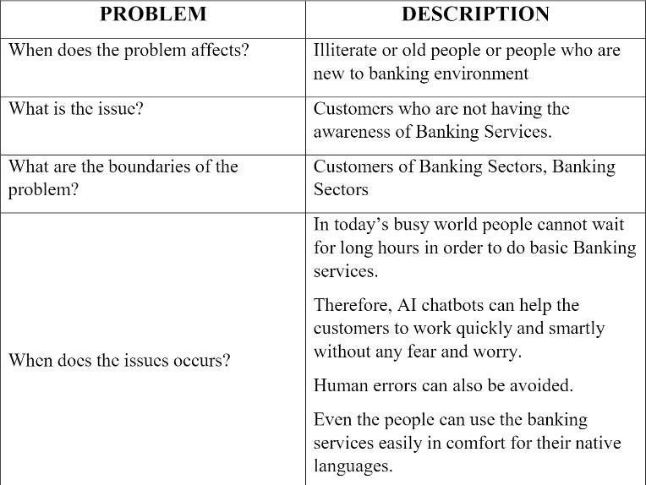

1. **IDEATION & PROPOSED SOLUTION**
   1. **Empathy Map Canvas**

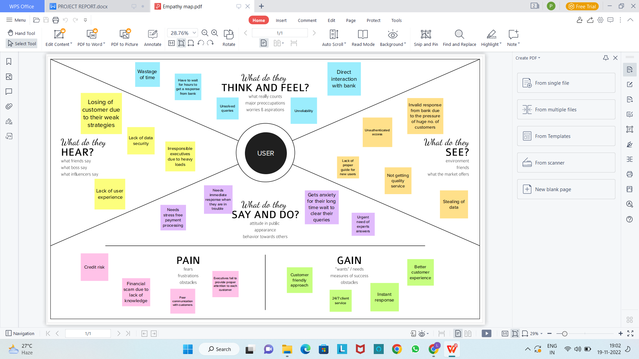

* 1. **Ideation & Brainstorming**

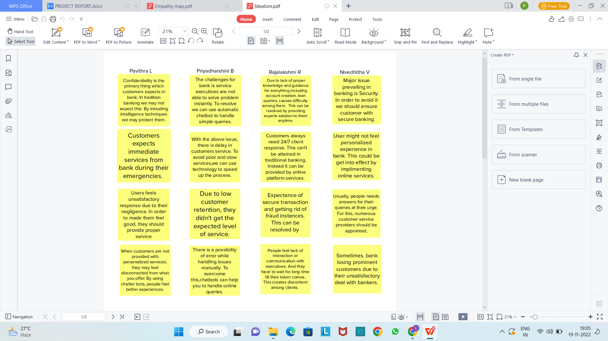

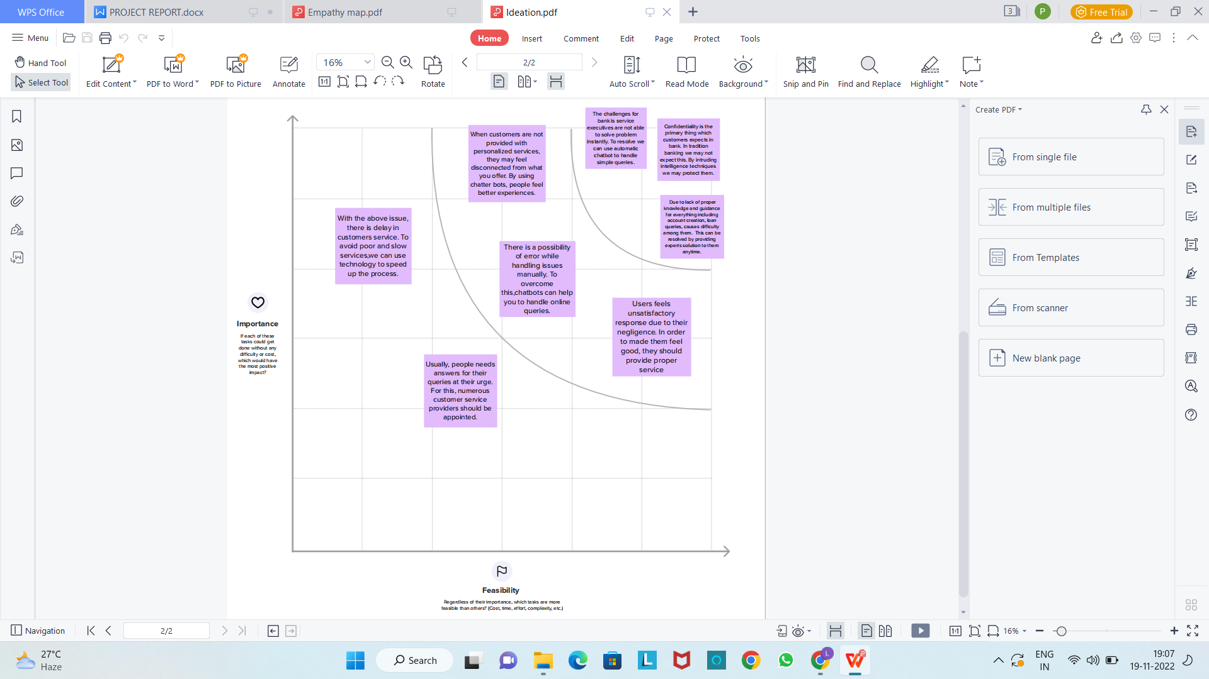

**Proposed Solution**

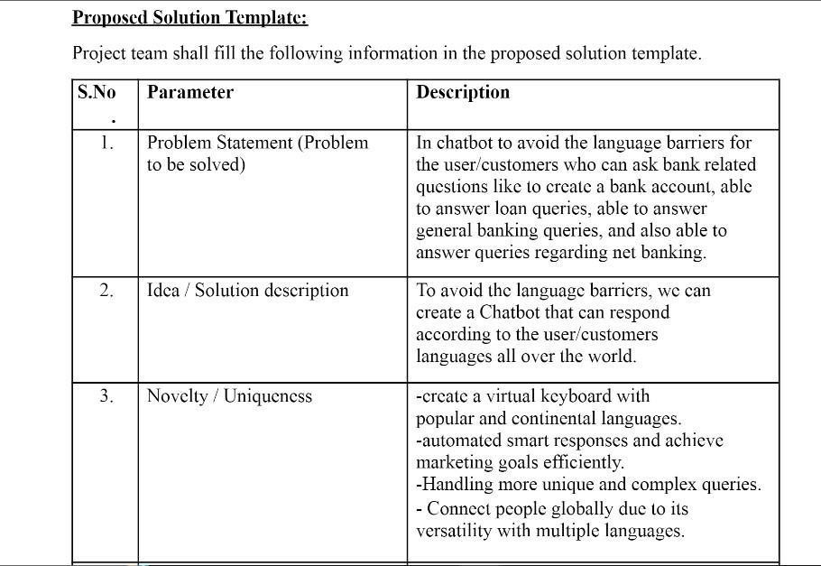

* 1. **Problem Solution fit**

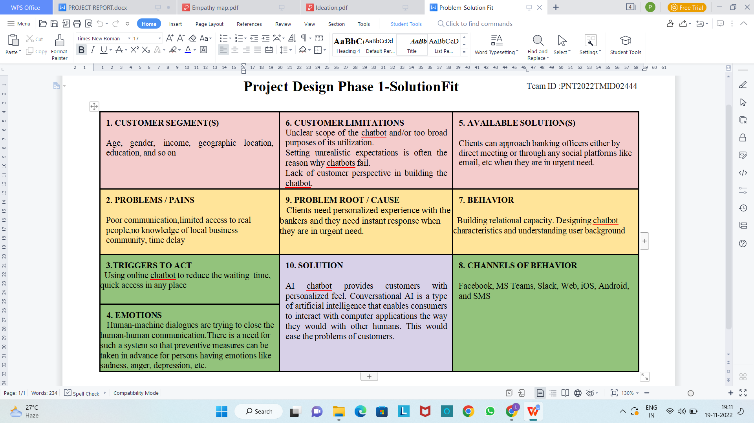

1. **REQUIREMENT ANALYSIS**
   1. **Functional requirement**

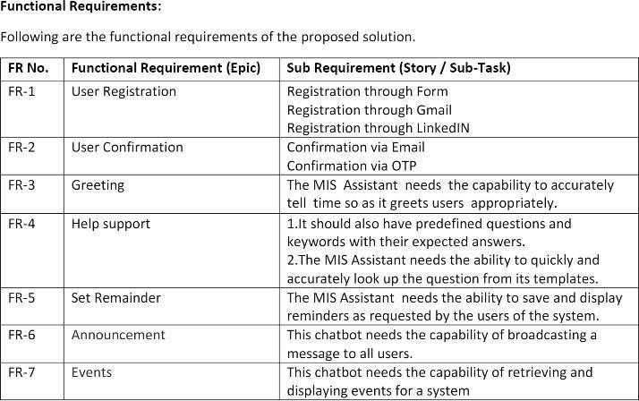

* 1. **Non-Functional requirements**

Web application is a software or application that can be accessed through the internet using multiple web browsers, Sometimes people think website and web applications are same but actually not in website client can only read the context of the page he has no ability to change the data of the page but in web application user can read and change the data as well chat bot is a system in web application that is a computer program which is enabled with artificial intelligence technology to do conversation via voice or text methods. The artificially intelligent system is designed in such a way that it will answer the query in a way like a human does. The Al gives the chatbox system to reach the next stage. The advances of Artificial Intelligence improved to the place where chat bots can not only perform the dialogue with people but also they can perform the task which are necessary for us.

In the field of software engineering requirements are needed at first. Similarly to build a web application some requirements are needed which are catagorized into two parts, functional requirements and non functional requirements Non-functional requirements deal with any software that how should this software work. In this paper we discuss about the non-functional requirements of web application based on chat bot. We will discuss various non-functional requirements such as:Accuracy permance security based on chat bot. To build a software or to build a web application it is necessary to focus on the requirements. Otherwise the web application can't give the client satisfiction. For that the software or the web application can't improve itself So it is the must discussed topic to focus on the requirements.

# PROJECT DESIGN

## Data Flow Diagrams

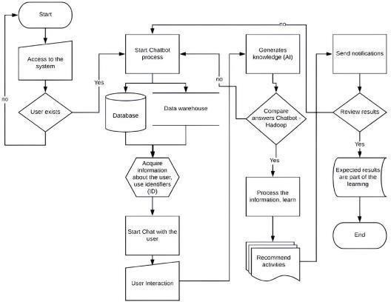

* 1. **Solution & Technical Architecture**

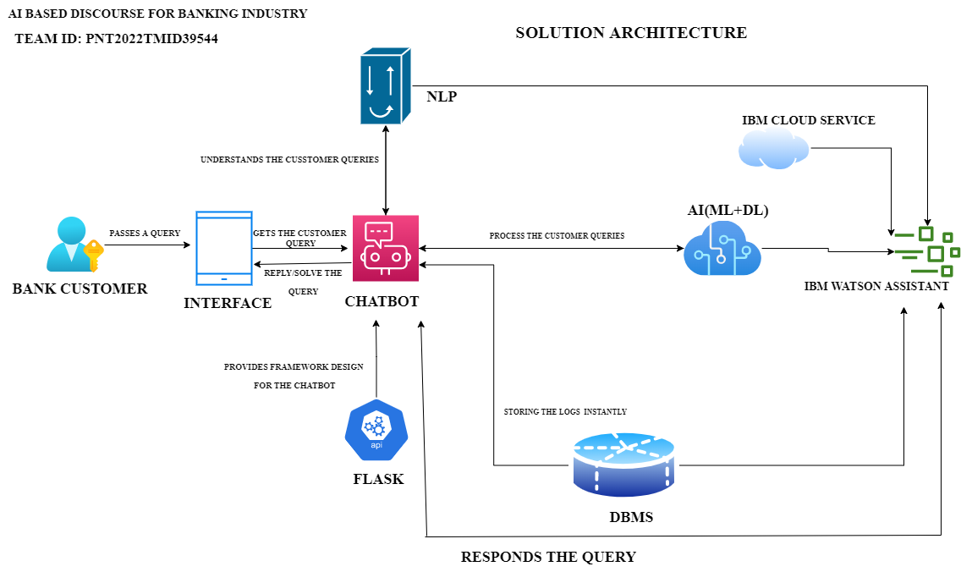

* 1. **User Stories**

User stories are a vital tool in the design and testing of chat bots. They are stories about fictional users, what they want, and how they will interact with your bot. When we create a user story, it needs to be as close to a real user as possible. They should be based on a real user or the type of user that would be using your chat bot. If you have existing customers that you are wanting to target your chat bot toward then you can create data-driven user stories.

# PROJECT PLANNING & SCHEDULING

## Sprint Planning & Estimation

Sprint is a part of the Scrum framework. In Scrum, large projects are broken down into a series of iterations of smaller manageable bits that teams can handle. These iterations are called sprints. A Sprint is a time-boxed period during which a Scrum team must complete an amount of work. Sprints are pivotal to the Scrum framework, and companies can help teams produce high- quality software faster and more frequently if they get them right. Furthermore, when teams work in Sprints, they enjoy more flexibility and become more adaptable. Manage project status, plan sprints, and create insightful reports to drive data-driven decisions in Gmail with the Gmail extension**.**

## Sprint Delivery Schedule

Sprint planning is an event in scrum that kicks off the sprint. The purpose of sprint planning is to define what can be delivered in the sprint and how that work will be achieved. Sprint planning is done in collaboration with the whole scrum team. However, before you can leap into action you have to set up the sprint. You need to decide on how long the time box is going to be, the sprint goal, and where you're going to start. The sprint planning session kicks off the sprint by setting the agenda and focus.

## Reports from JIRA

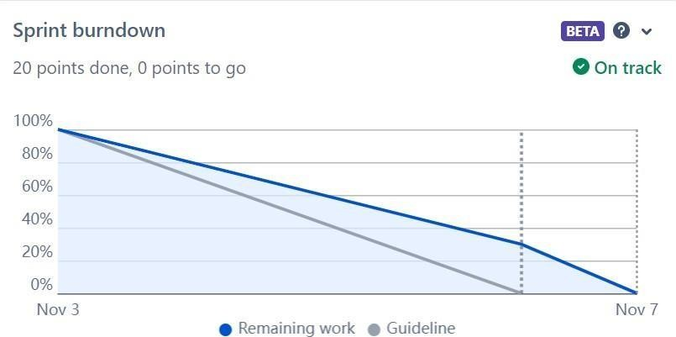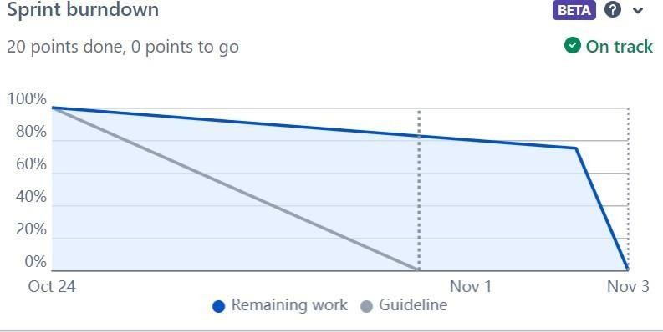

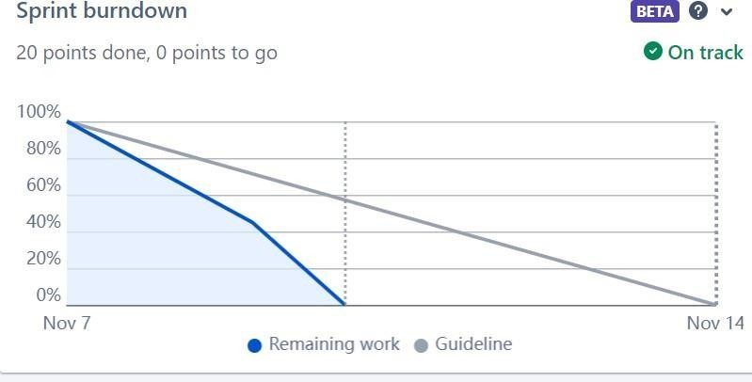

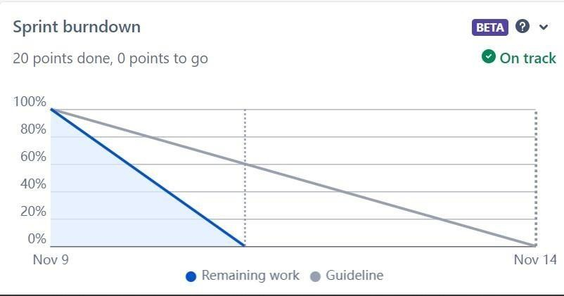

1. **CODING &amp; SOLUTIONING**
   1. **Feature 1**

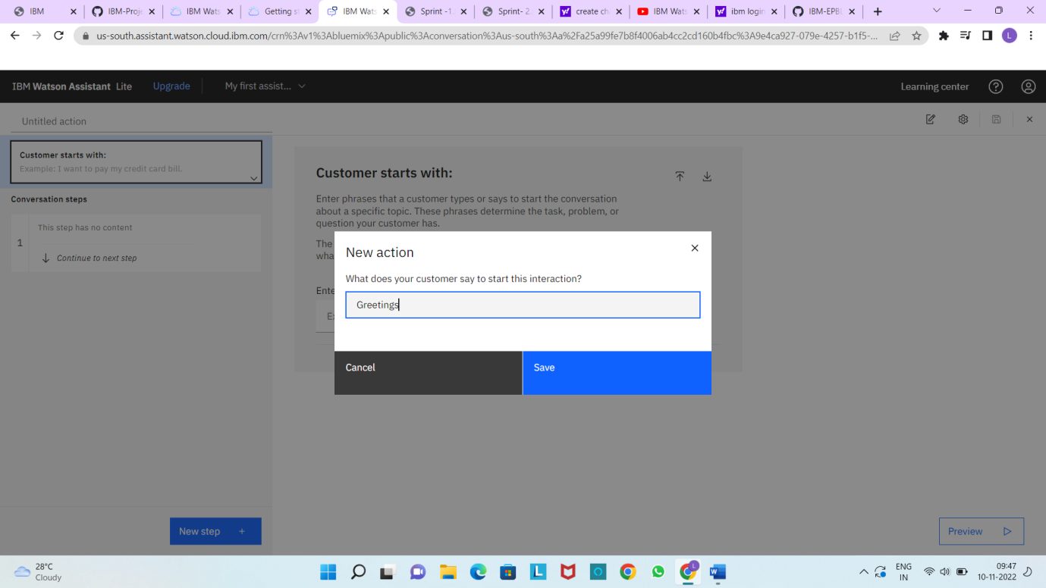

* 1. **Feature 2**

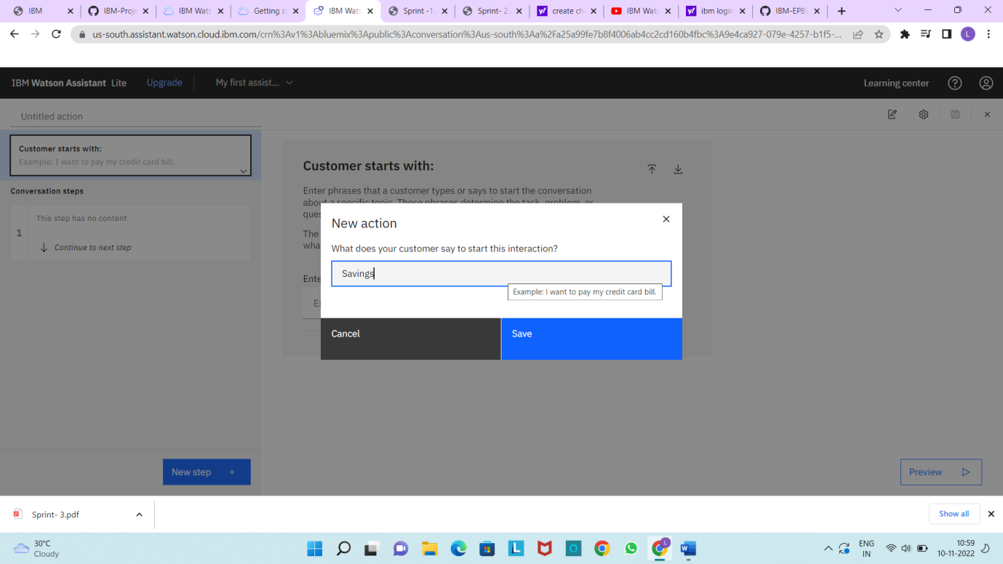

**Current account**



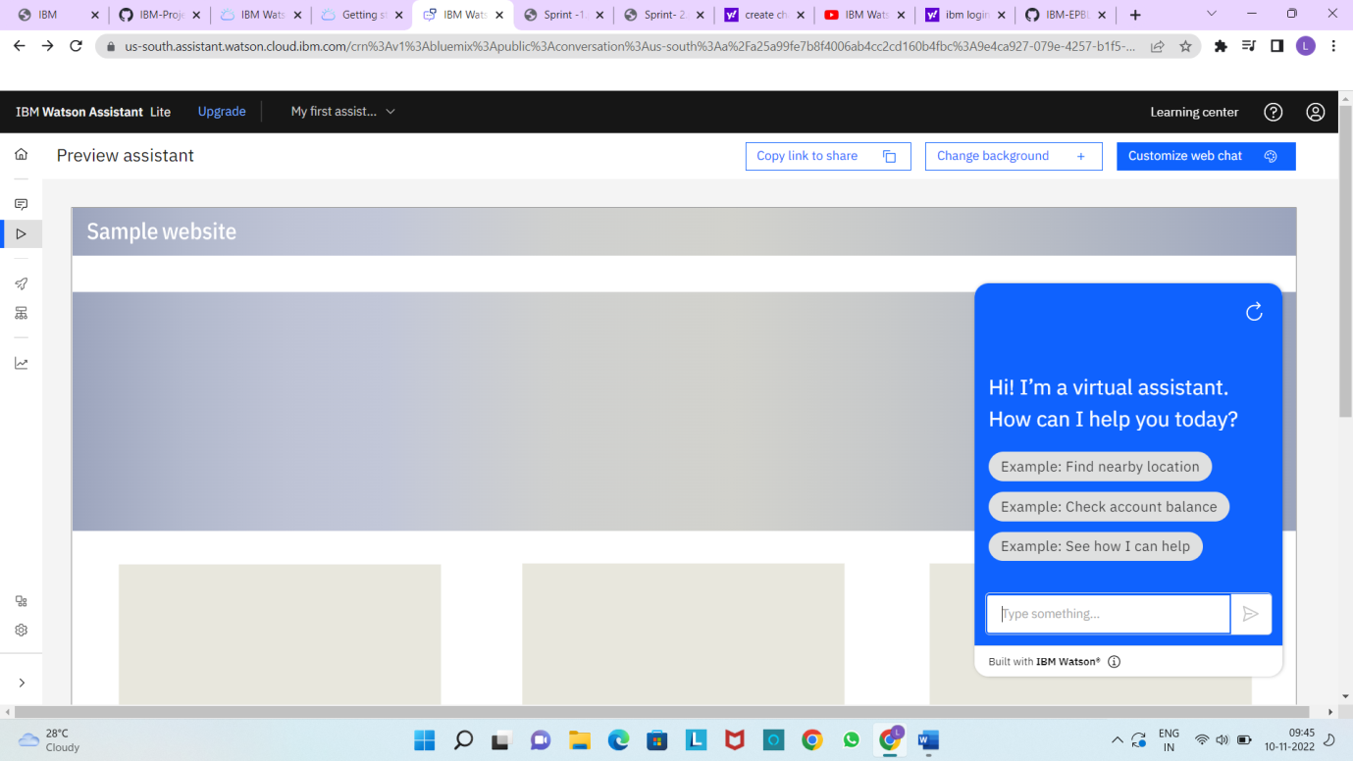

1. **TESTING**
   1. **Test Cases**

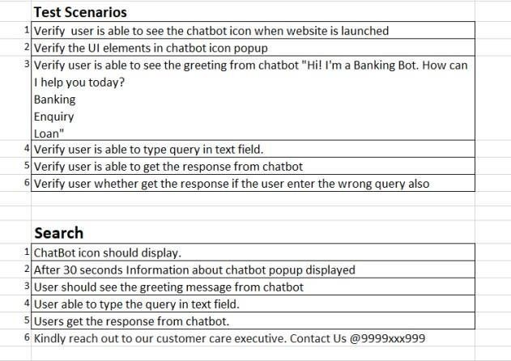

* 1. **User Acceptance Testing**

UAT Execution & Report Submission

## A Purpose of Document

The purpose of this document is to briefly explain the test coverage and open issues of the AI-based discourse for Banking Industry project at the time of the release to User Acceptance Testing (UAT).

B Defect Analysis

This report shows the number of resolved or closed bugs at each severity level, and how they were resolved.

|  |  |  |  |  |  |
| --- | --- | --- | --- | --- | --- |
| **Resolution** | **Severity 1** | **Severity 2** | **Severity 3** | **Severity 4** | **Subtotal** |
| By Design | 1 | 0 | 0 | 0 | 1 |
| Duplicate | 3 | 1 | 0 | 1 | 5 |
| External | 1 | 3 | 0 | 1 | 5 |
| Fixed | 2 | 5 | 3 | 2 | 12 |
| Not Reproduced | 0 | 0 | 0 | 1 | 1 |
| Skipped | 0 | 0 | 0 | 0 | 0 |
| Won't Fix | 0 | 0 | 0 | 0 | 0 |
| Totals | 7 | 9 | 3 | 5 | 24 |

## C Test Case Analysis

This report shows the number of test cases that have passed, failed, and untested.

|  |  |  |  |  |
| --- | --- | --- | --- | --- |
| **Section** | **Total Cases** | **Not Tested** | **Fail** | **Pass** |
| Print Engine | 1 | 0 | 0 | 1 |
| Client Application | 1 | 0 | 0 | 1 |
| Security | 1 | 0 | 0 | 1 |
| Outsource Shipping | 0 | 0 | 0 | 0 |
| Exception Reporting | 1 | 0 | 0 | 1 |
| Final Report Output | 1 | 0 | 0 | 1 |
| Version Control | 1 | 0 | 0 | 1 |

# PERFORMANCE TESTING

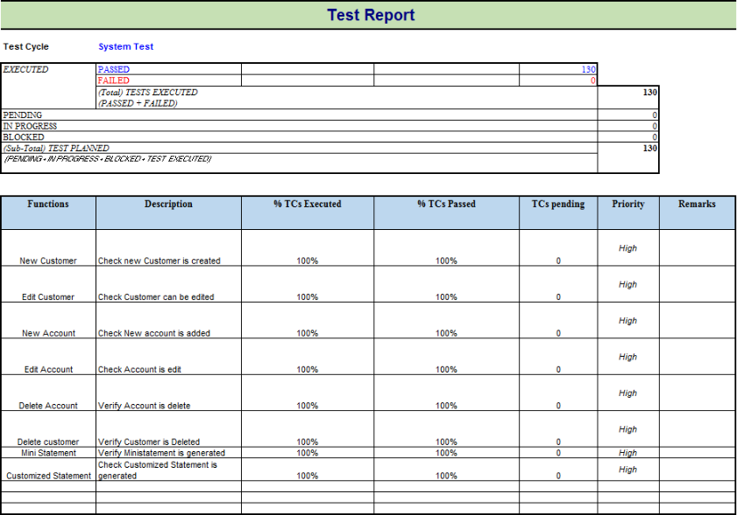

1. **RESULTS**

## Performance Metrics

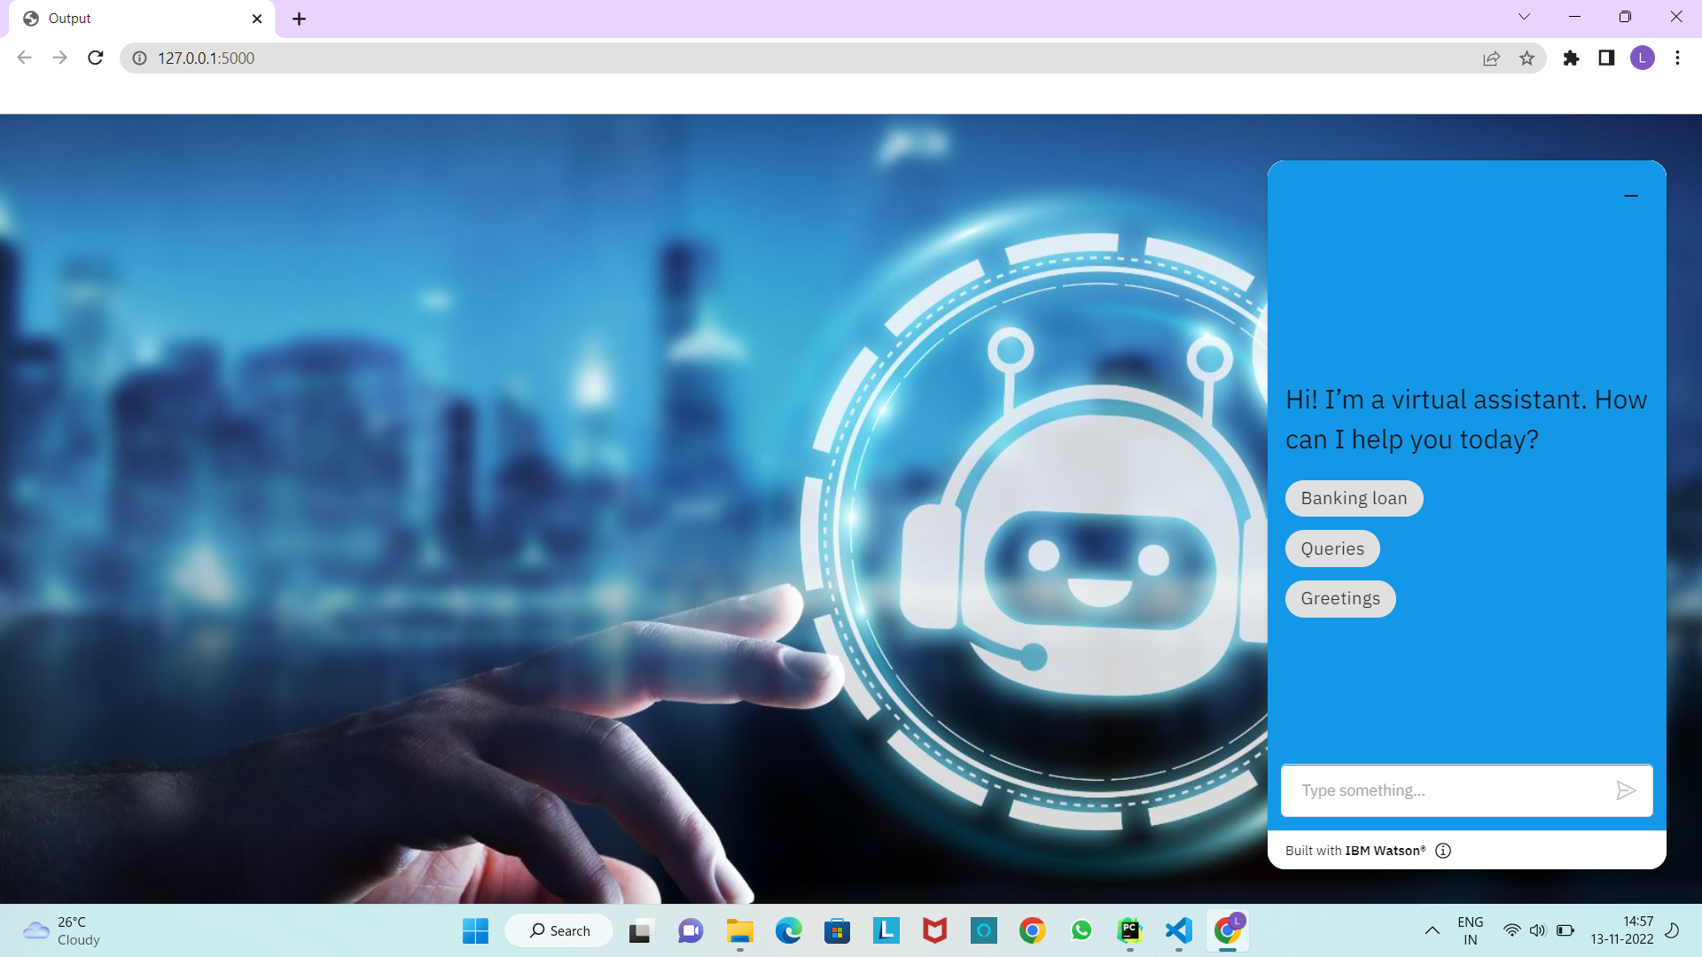

1. **ADVANTAGES &amp; DISADVANTAGES**

**ADVANTAGES**

1. chat bots have 24/7 Availability: chat bots can be available to solve customer problems 24/7 whether it is day or night! They don’t need to sleep after all! This is much more difficult to achieve using human customer service as it would require rotating teams that would be more complicated to manage as well.
2. chat bots can gather Customer Insights: Companies thrive on customer data! The more data they have, the better they can cater to their customers and be much more successful. That’s where chat bots can be a big help. Whenever you interact with any chat bots on a company page, you provide basic data such as user preferences, buying habits, sentiments, etc. which can then be analysed to understand market trends, operational risks, etc. And using this information, the company can solver customer issues much easier and create targeted products. This will help in increasing their customer loyalty!

## DISADVANTAGES

* 1. chat bots sound too Mechanical: chat bots are not human and so obviously they cannot interact as a human with customers. They sound too mechanical and can only give answers to problems that they have been programmed with. They cannot answer a customer according to the context and they cannot show any emotions if needed. chat bots also cannot maintain a natural-sounding conversation in-depth with customers and that is why they are only useful in solving basic queries. But this can create a disconnect with customers who prefer the human approach when solving their problems.
  2. chat bots can only handle basic Questions: chat bot are still a basic Artificial Intelligence technology and so they can only answer the basic questions of customers and provide general information that is already available to them. They cannot solve complicated queries or answer out of script questions and companies need to have human customer service employees that can manage these for them. However, this is changing with time and currently, more and more advanced chat bots are entering the market.

# CONCLUSION

In this paper we have provided a survey of relevant works of literature on the subject, and we have analysed the state of the art in terms of language models, applications, datasets used, and evaluation frameworks. We have also underlined current challenges and limitations, as well as gaps in the literature. Despite technological advancements, AI chat bots are still unable to simulate human speech. This is due to a faulty approach to dialogue modeling and a lack of domain-specific data with open access. For Information Retrieval chat bots, there is also a lack of a learnt AI model. There is still a gap to be closed in terms of applications between Industry models and current advancements in the sector. Large models necessitate a lot of computing power and a lot of training data. There is no universal framework for evaluating chat bots. Several models depend on human evaluation, yet human evaluation is expensive, time- consuming, difficult to scale, biased, and lacks coherence. A new, reliable automatic evaluation approach should be provided to overcome these restrictions.

# FUTURE SCOPE

chat bots are Now Based on Natural Language Processing(NLP)

The goal is to allow users and Artificial Intelligence to communicate naturally and understand complex requests. This would mean that customer service agents would be able to focus on other tasks while the AI takes care of customers' queries. chat bots in finance, in the digital banking and healthcare industries might save more than 12 billion USD in a year by 2022. According to several estimates, financial organizations might save 2 trillion USD by 2030by implementing artificial intelligence and cutting costs by 35%.In the digital banking business, banks with chat bots can automate a variety of functions in addition to enhancing everyday operations and the universal consumer experience as fund transfer, Notifications & Alerts at the Right Time, Get help from a Customer Service Representative, simple lead generation.

# 13.APPENDIX

## Source Code:

chatbot*.HTML*

<!DOCTYPE html>  
<html lang="en">  
<head>  
 <meta charset="UTF-8">  
 <title>Output</title>  
 <link rel="stylesheet" href="https://maxcdn.bootstrapcdn.com/bootstrap/3.4.1/css/bootstrap.min.css">  
 <style>  
 body  
 {  
 background-image: url("https://www.santanderassetmanagement.es/wp-content/uploads/2018/07/chatbots.jpg");  
 background-size: cover;  
 }  
 </style>  
</head>  
<body>  
<script>  
 ***window***.watsonAssistantChatOptions = {  
 integrationID: "45c211e5-94a4-493f-b22d-f2114f9c6dc2", // The ID of this integration.  
 region: "us-south", // The region your integration is hosted in.  
 serviceInstanceID: "9e4ca927-079e-4257-b1f5-9778ef4f3506", // The ID of your service instance.  
 onLoad: function(instance) { instance.render(); }  
 };  
 setTimeout(function(){  
 const t=***document***.createElement('script');  
 t.src="https://web-chat.global.assistant.watson.appdomain.cloud/versions/" + (***window***.watsonAssistantChatOptions.clientVersion || 'latest') + "/WatsonAssistantChatEntry.js";  
 ***document***.head.appendChild(t);  
 });  
</script>  
</body>  
</html>

Python source code

App.py

from flask import Flask, render_template  
  
app = Flask(__name__)  
  
  
@app.route('/')  
def hello_world(): # put application's code here  
 return render_template("chatbot.html")  
  
  
if __name__ == '__main__':  
 app.run()